Digger Wrestling

2020 Dick Stanley Memorial
AAU Youth Wrestling Tournament

Saturday, February 15th 2020
Lead/Deadwood High School, 320 S. Main Street, Lead, SD

Registration/Weigh-Ins: Pre-Registration REQUIRED (no on-site registration)
www.trackwrestling.com by Noon, Friday, February 14th
Mandatory Weigh-ins: Friday, February 14th 5pm – 7pm
Saturday, February 15th – 6:30am - 8:00am
AAU card and copy of birth certificate required for all wrestlers upon check in

Coaches Meeting: 8:30 a.m. Wrestling Begins: 9:00 a.m.

Entrance Fees: $10.00 per wrestler, $5.00 per coach/adult, $3 per student
(non-wrestlers under 5 are free)

Coaches: MUST show their Non-Athlete AAU card to receive a coach’s band.
(No additional charge for coach’s band)

Only coaches w/bands and wrestlers “on deck” will be allowed on the floor & mat side.
All others (parents & wrestlers not on deck) will be asked to sit in the stands.

Bracket: 5-Man Round Robin - Three 1 ½ minute periods - Track wrestling will be used

Awards: Trophies – 1st place Medals–2nd - 5th place
(must wrestle at least one match to receive an award)

Sportsmanship Team Award!

Age Categories: 6-U, 7-8, 9-10, 11-12, 13-14 (AAU age - age in 2020)
Girls will wrestle with the boys

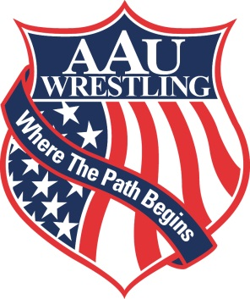
Breakfast: Served from 6:30 a.m. to 9:30 a.m.
Concessions: Large selection provided - NO COOLERS PLEASE!

Contact Info: Wendy Janke (605) 920-1010 Robin Lucero (605) 580-0172

Not Responsible For Accidents Or Lost Property

This event is licensed by the Amateur Athletic Union of the U. S., Inc.
All participants must have a current AAU membership.
AAU membership may not be included as part of the entry fee to the event.
AAU membership must be obtained before the competition begins except where the event operator has a laptop available with an internet connect. Participants are encouraged to visit the AAU web site www.aausports.org to obtain their membership.

